SECTION 9 - Reliability,Availability, and disaster recovery
—-------------------------------------------------

System Reliability- Correctness,Consistency, Fault Tolerance, Availability(Uptime)

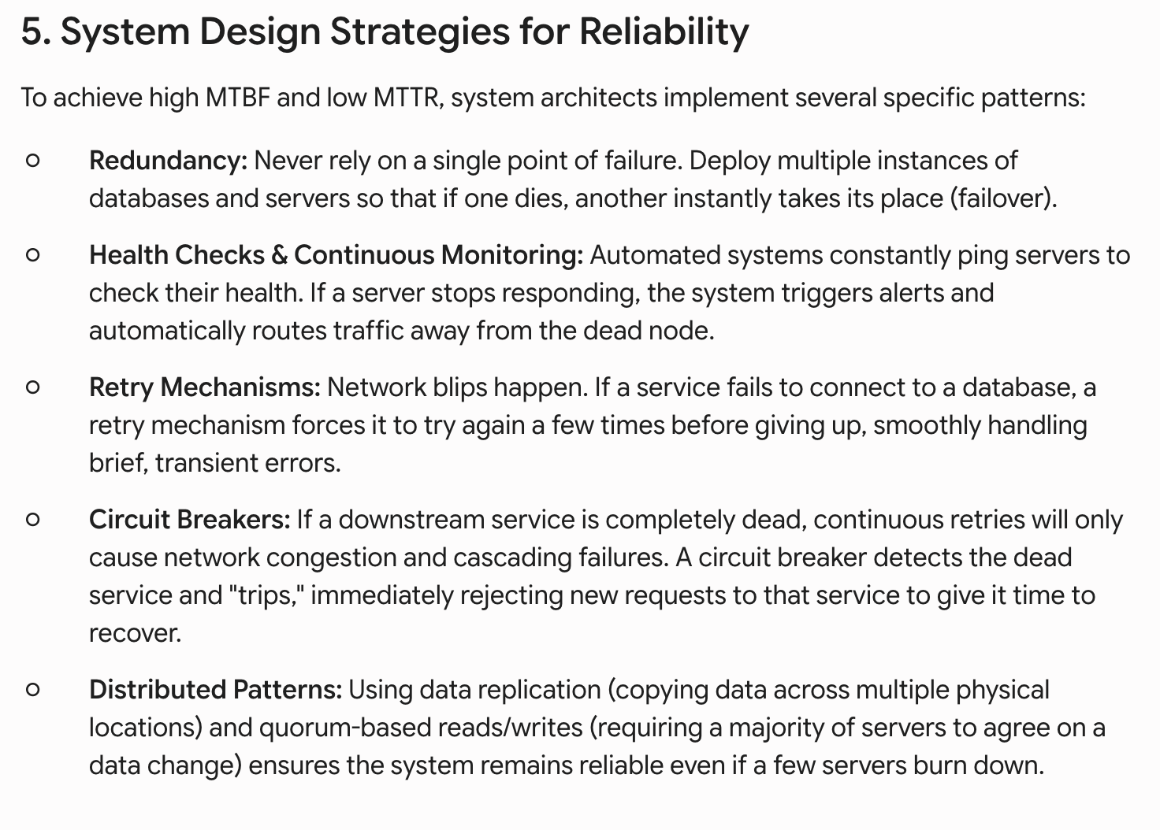
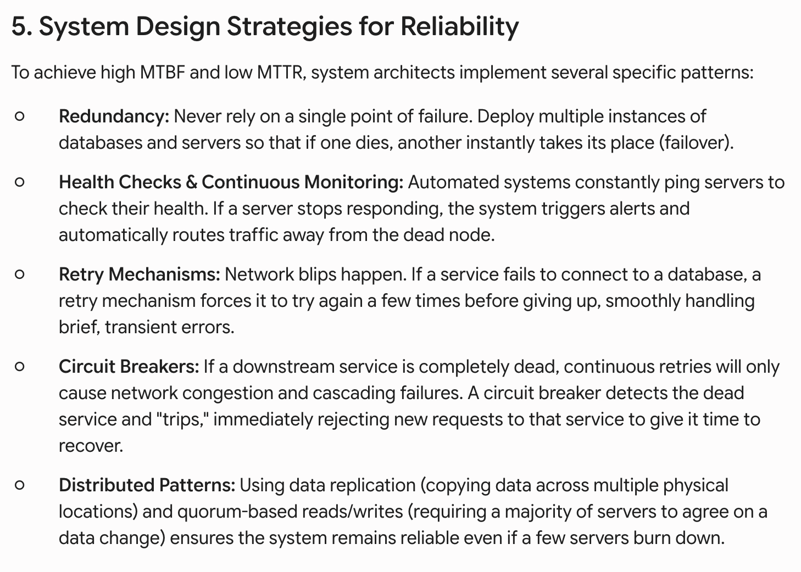
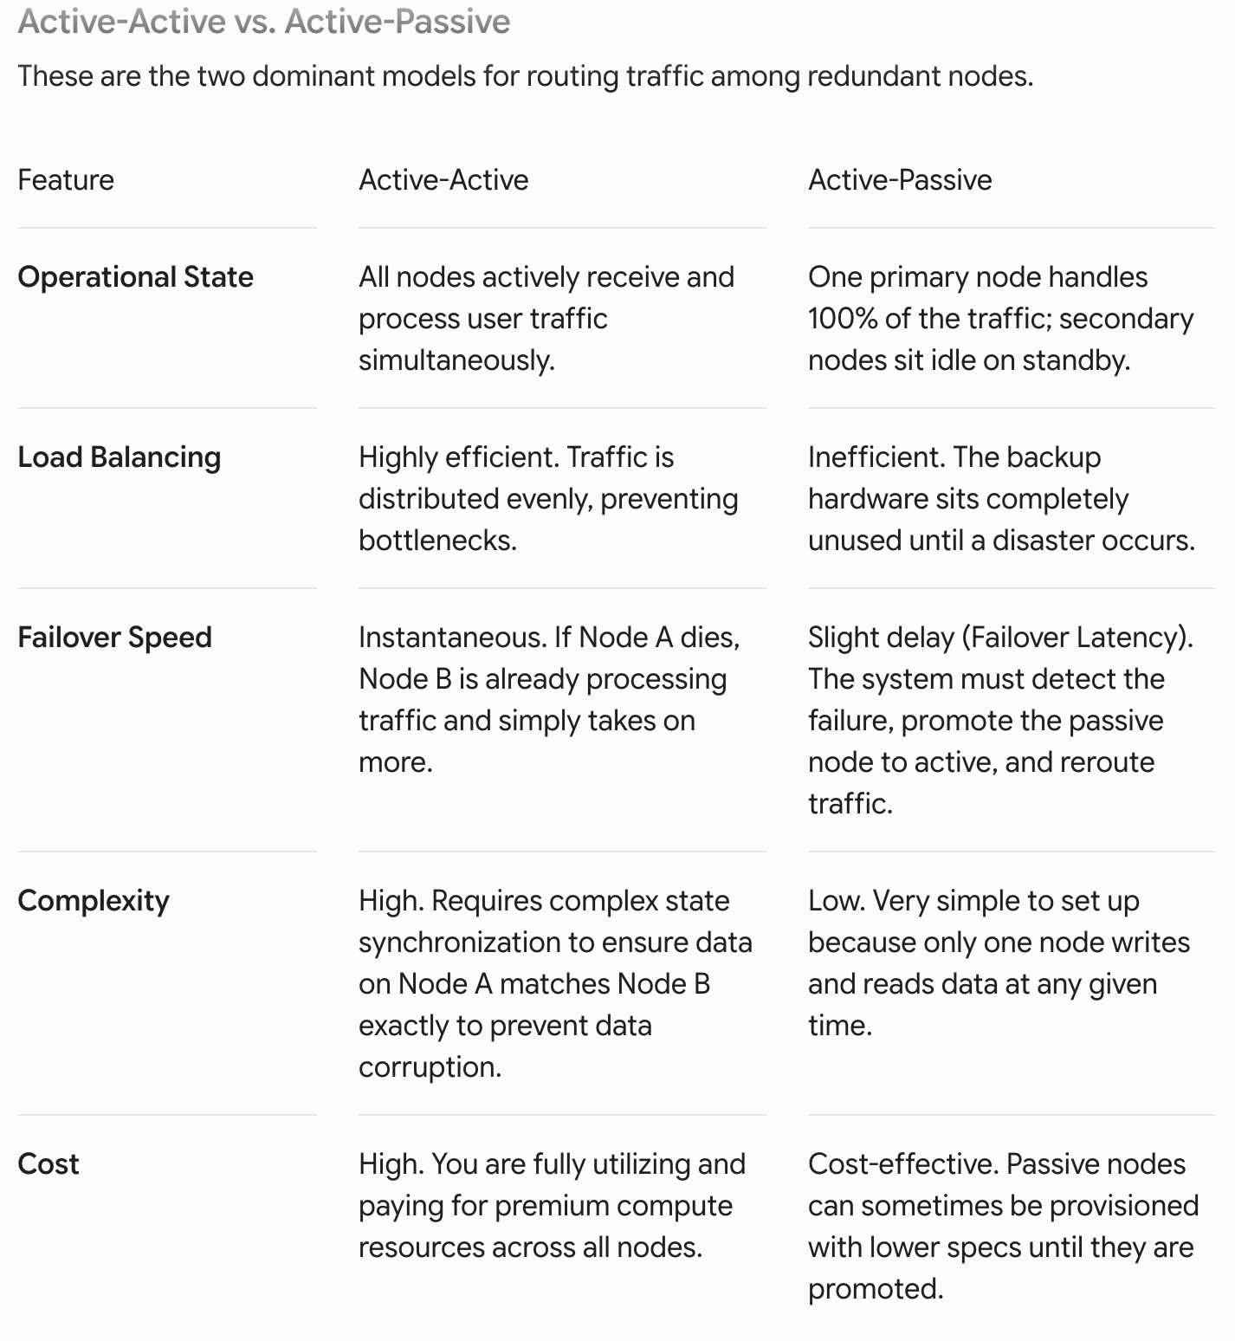
Backup Type | How It Works | Pros | Cons
Full Backup | Copies absolutely every piece of data in the system, every single time it runs. | Simplest to manage and offers the fastest recovery time because all data is in one place. | Extremely storage-heavy, expensive, and takes a long time to execute, straining system resources.
Incremental Backup | Copies only the data that has changed since the last backup (whether that last backup was full or incremental). | Very fast to execute and highly storage-efficient. | Slowest recovery time. To restore, you must load the last Full Backup, plus every single incremental file in sequential order.
Differential Backup | Copies only the data that has changed since the last full backup, ignoring any differential backups taken in between. | Faster recovery than incremental because you only need two files: the Full Backup and the most recent Differential Backup. | Requires more storage space than incremental backups, as the daily backup file grows larger as the week progresses.
\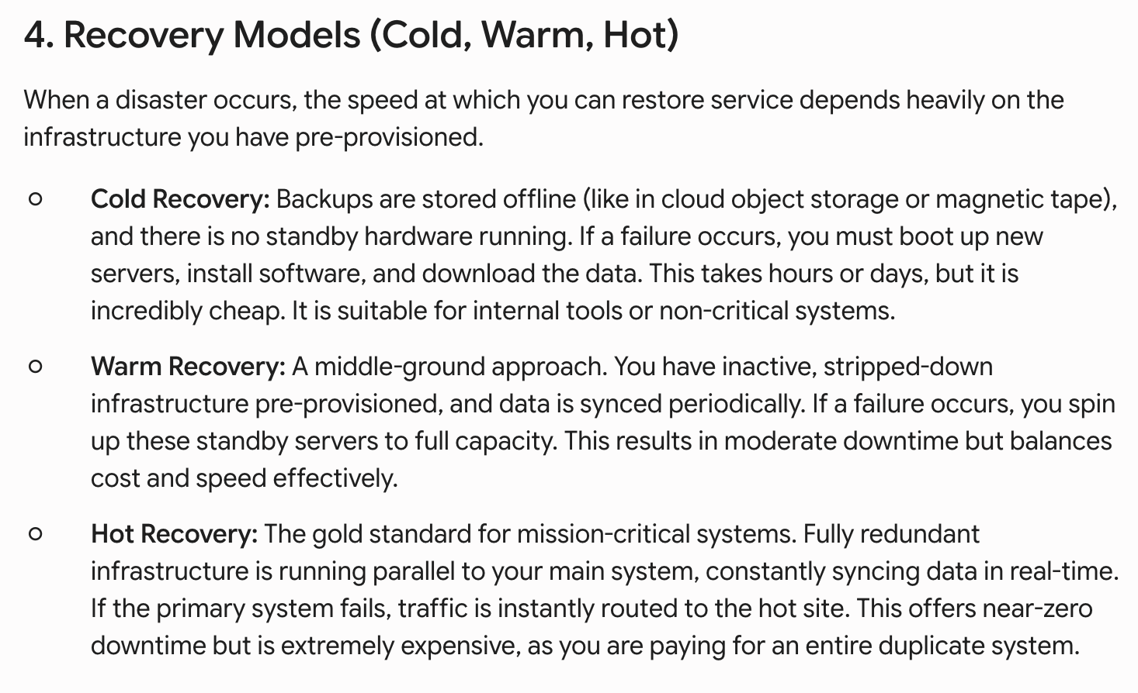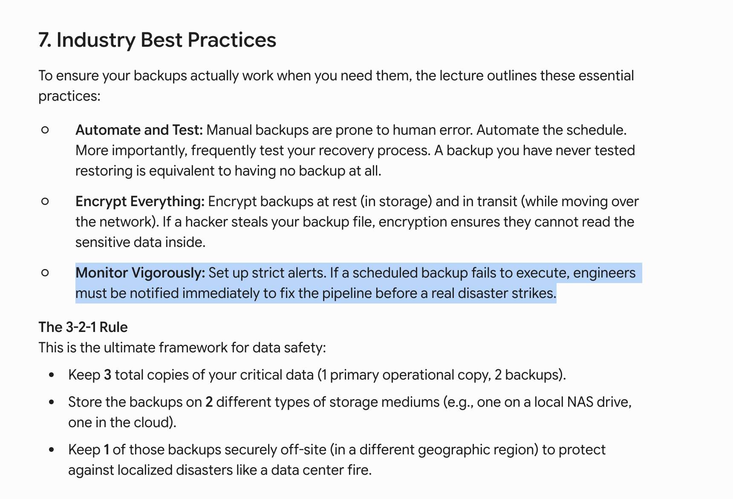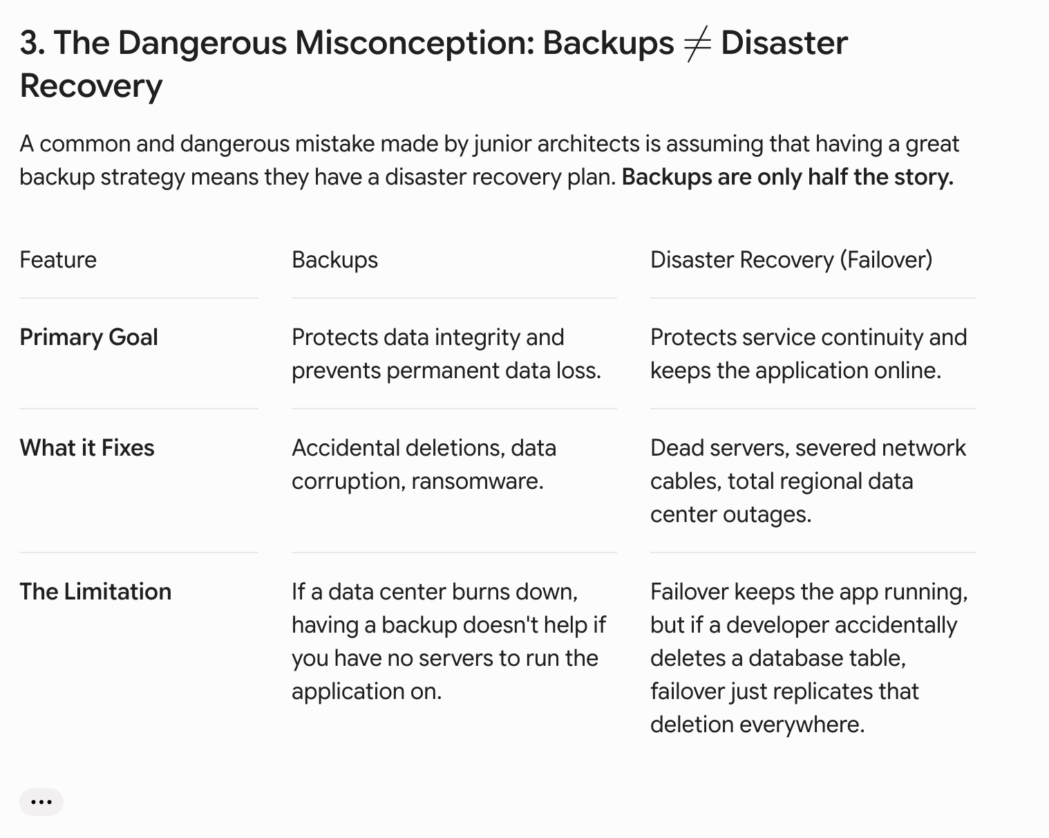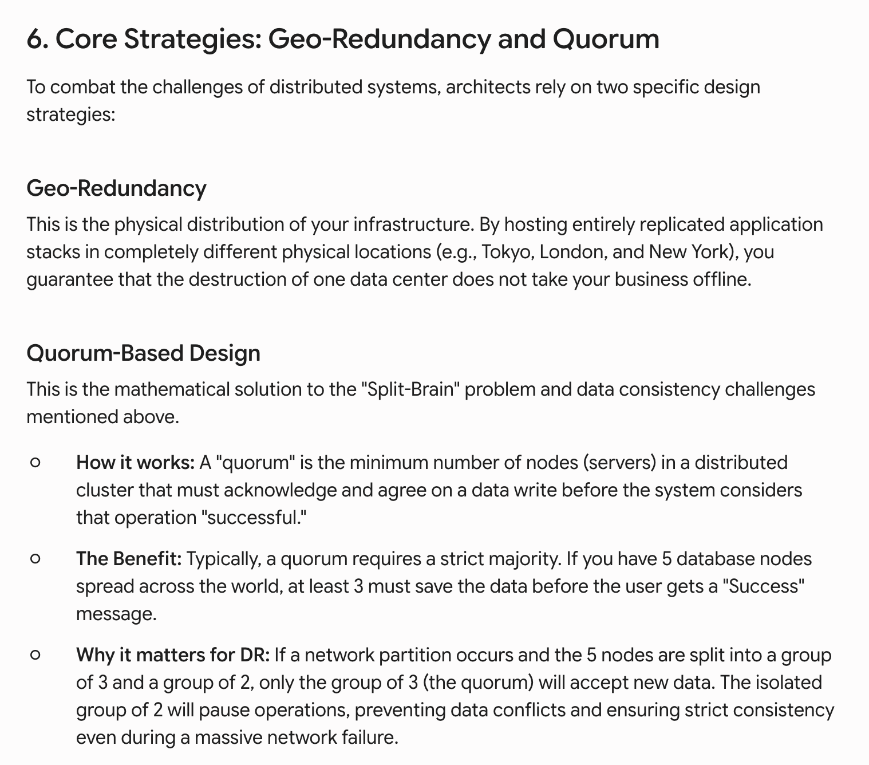Split-Brain Scenarios: If the network link between Region A and Region B drops, both regions might think the other is dead. Both might try to become the "Primary" database, accepting writes independently. When the connection is restored, the data is hopelessly conflicted. Coordinating multi-region failovers requires flawless orchestration to prevent this.

